Title: **Multi-load Loaded Voltage Divider** Lab: 18

Course: Electrical Applications Unit: Electrical Lab CLO: 2, 3, 4

Name ANSWER KEY Grade 67pts. Date ______________

**Objectives**

1. Student shall calculate multi-load, loaded voltage divider circuit quantities using the characteristics of a series and a parallel circuit and a given *load*.
2. Student shall construct the circuit and analyze the results.

**Assessment**

Students shall demonstrate a comprehension of the objectives listed above by scoring a minimum of 75% on this Lab. Grading shall be based on instructor evaluation.

**Materials**

|  |  |
| --- | --- |
| Student Provided Materials | Department Provided |
| Proto-Board | Power Supply |
| Multimeter |  |
| Resistor Kit |  |
| Calculator |  |

**Theory**

A multi-load loaded voltage divider is an active series-parallel circuit that produces multiple output load voltages (EL1, EL2, etc.) that are fractions of its input voltage (ES). Voltage division is the result of distributing the input voltage among the components of the divider.

**Circuit**

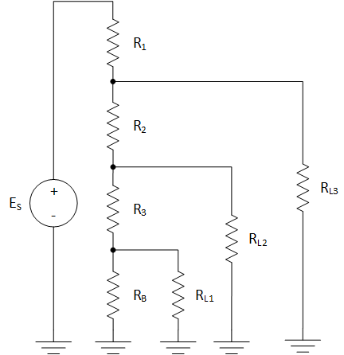

Where;

$$E_{S}=12V, E_{L1}=2V, E_{L2}=3V, E_{L3}=7V, I_{L1}=9.1mA, I_{L2}=1.1mA, I_{L3}=2.1mA$$

**Instructions**

Calculations

1. Compute the following values based on the Ohm’s Wheel and the information given on the pervious page.

|  |  |  |  |  |
| --- | --- | --- | --- | --- |
|  | P | I | R | E |
| R1 | 68.333mW | 13.667mA | 365.854Ω | 5V |
| R2 | 46.267mW | 11.567mA | 345.821Ω | 4V |
| R3 | 10.467mW | 10.467mA | 95.541Ω | 1V |
| RB | 2.733mW | 1.367mA | 1.463kΩ | 2V |
| RL1 | 18.2mW | 9.1mA | 219.78Ω | 2V |
| RL2 | 3.3mW | 1.1mA | 2.727kΩ | 3V |
| RL3 | 14.7mW | 2.1mA | 3.333kΩ | 7V |
| Total | 164mW | 13.667mA | 878.049Ω | 12V |

Measurements

1. Construct the circuit on the previous page. Take measurements and complete the table below.

|  |  |  |  |  |
| --- | --- | --- | --- | --- |
|  | P | I | R | E |
| R1 |  |  |  |  |
| R2 |  |  |  |  |
| R3 |  |  |  |  |
| RB |  |  |  |  |
| RL1 |  |  |  |  |
| RL2 |  |  |  |  |
| RL3 |  |  |  |  |
| Total |  |  |  |  |

Evaluations

1. What would be the effect of increasing the value of RB on IT?
   1. Go Up
   2. Go Down
   3. Stayed the same
2. What would be the effect of increasing R2 on EL3?
   1. Go Up
   2. Go Down
   3. Stayed the same
3. What would be the effect of increasing RL2 on EL1?
   1. Go Up
   2. Go Down
   3. Stayed the same